DETAILS
NAME: LINGAM.KAVYA SRI
SECTION: CSE 1
ROLL NO: 26000035

PYTHON ACTIVITY 1
CASE STUDIES 21-30
21.Traffic Violation Penalty Calculator
22.Laboratory Chemical Inventory Validation
23.Student Timetable Conflict Detection
24.Courier Charge Optimization
25.Progressive Water Tariff Analysis
26.Nested Loop Examination Seating Generator
27.Advanced Numeric Pattern Generator
28.Repeated Transaction Detection
29.Password Policy Validation Engine
30.Student Email and Identifier Validation

CASE STUDY-21: Traffic Violation Penalty Calculator
1.Problem statement
To develop a Python program to calculate traffic violation fines based on vehicle category, offence type, and repeat offences.
2. Objectives
- To identify the type of traffic violation.
- To calculate the applicable fine.
- To check whether the offence is repeated.
- To display the final penalty.
3. Assumptions
- Two-wheeler and car are the vehicle categories.
- Helmet violation fine is ₹500.
- Overspeeding fine is ₹1,000.
- Repeat offences have an additional fine of ₹500.
- These are hypothetical values for this assignment.
4. Algorithm
- Start.
- Read vehicle category and offence type.
- Check the offence and calculate the fine.
- Check whether it is a repeat offence.
- Add the extra fine if repeated.
- Display the total penalty.
- Stop
5.Flow chart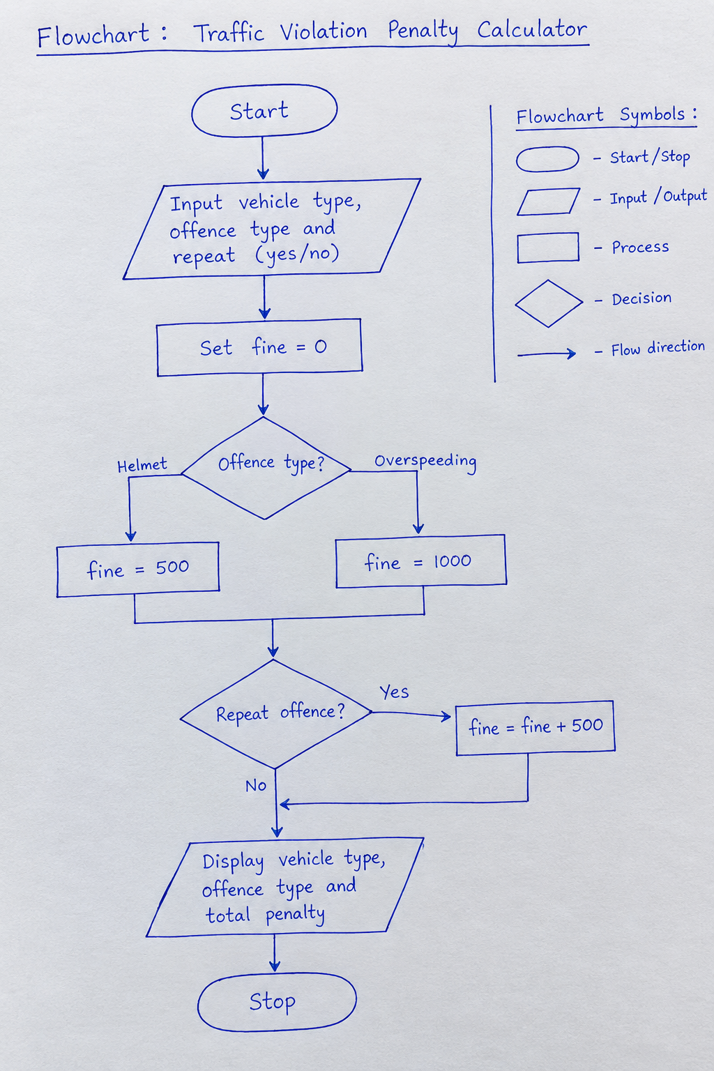
6. Pseudocode
START
INPUT vehicle, offence, repeat
IF offence is helmet violation
fine = 500
ELSE IF offence is overspeeding
fine = 1000
ELSE
fine = 0
IF repeat is yes
fine = fine + 500
PRINT fine
STOP
7.Python Program
vehicle = input("Enter vehicle type: ")
offence = input("Enter offence (helmet/over speeding): ")
repeat = input("Is it a repeat offence? (yes/no): ")

if offence == "helmet":
fine = 500
elif offence == "over speeding":
fine = 1000
else:
fine = 0
print("Invalid offence type")

if repeat == "yes":
fine = fine + 500

print("Vehicle:", vehicle)
print("Offence:", offence)
print("Total penalty: Rs.", fine)

8.Test cases

Offence | Repeat? | Expected fine
helmet | no | ₹500
overspeeding | no | ₹1,000
helmet | yes | ₹1,000
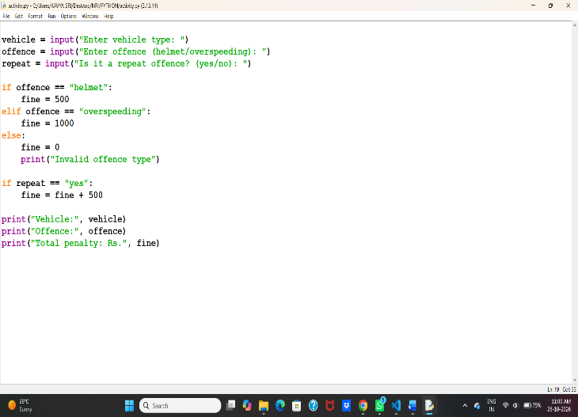

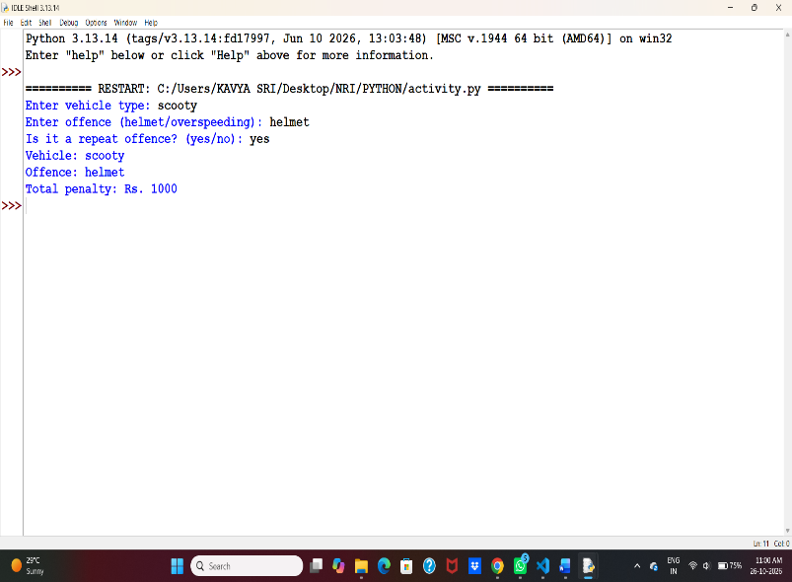

9. Sample Output
Enter vehicle type: car
Enter offence (helmet/overspeeding): overspeeding
Is it a repeat offence? (yes/no): no
Vehicle: car
Offence: overspeeding
Total penalty: Rs. 1000
10. Conclusion
This program calculates traffic violation penalties using conditional statements and displays the total fine based on the offence and repeat-offence status.

CASE STUDY 22: Laboratory Chemical Inventory Validation
1. Problem Statement
To develop a Python program to check laboratory chemical inventory records using storage categories, maximum quantity limits, and compatibility rules, and identify invalid records.
2. Objectives
- To store chemical names and quantities.
- To check maximum quantity limits.
- To validate storage categories.
- To display valid and invalid inventory records.
3. Assumptions
For this example, the following are hypothetical assignment rules:
- Maximum permitted quantity is 100 units per chemical.
- Each chemical must have a valid storage category.
- Chemicals stored in incompatible categories are flagged for review.
- The example uses fictional chemical labels and simplified rules, not real laboratory safety guidance.
4. Algorithm
- Start.
- Input the number of chemical records.
- Enter each chemical's name, category, and quantity.
- Check whether the quantity exceeds the allowed limit.
- Check whether any two categories are incompatible under the given sample rules.
- Display any errors found.
- If no errors are found, display “Inventory is valid.”
- Stop.

5.flow chart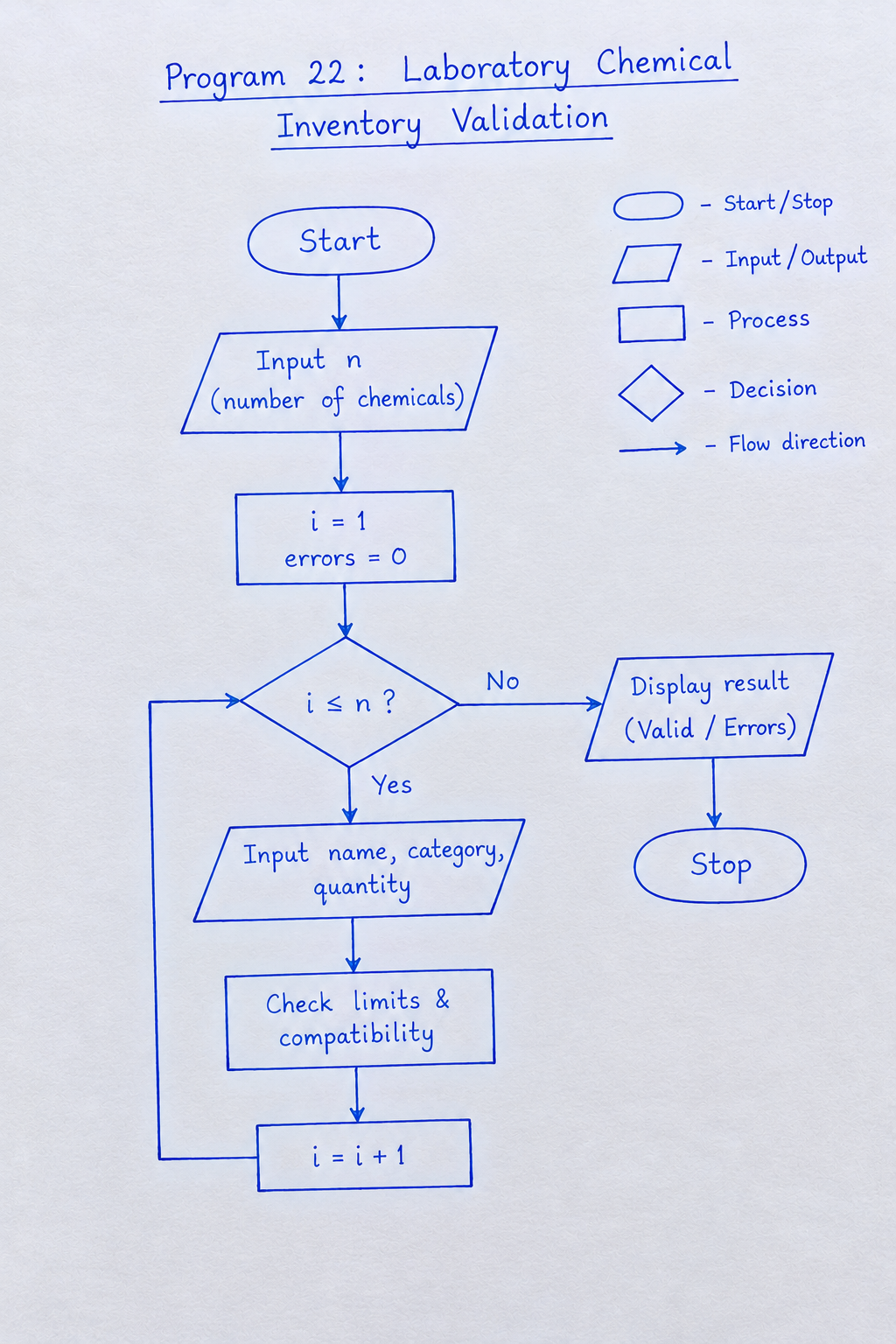6. Pseudocode
START
INPUT number of chemicals
SET errors = 0

FOR each chemical
INPUT name, category, quantity
CHECK quantity limit
CHECK compatibility rules
IF any rule is violated
DISPLAY error
SET errors = errors + 1
END IF
END FOR

IF errors = 0
DISPLAY "Inventory is valid"
END IF

STOP

7. Python program

n = int(input("Enter number of chemicals: "))
errors = 0

for i in range(n):
name = input("Enter chemical name: ")
category = input("Enter category: ")
qty = int(input("Enter quantity: "))

if category == "Acid" or category == "Base":
limit = 10
elif category == "Oxidizer" or category == "Toxic":
limit = 5
elif category == "Flammable":
limit = 8
else:
print("Invalid category")
errors += 1
continue

if qty < 0 or qty > limit:
print(name, "Invalid quantity")
errors += 1

if errors == 0:
print("Inventory is valid")

8. Test Cases
Test case | Input | Expected result
1 | Sample category Toxic, quantity 3 | Inventory is valid
2 | Sample category Acid, quantity 15 | Quantity exceeds limit
3 | Invalid category Water, quantity 2 | Invalid category
4 | Sample category Base, quantity -2 | Invalid quantity
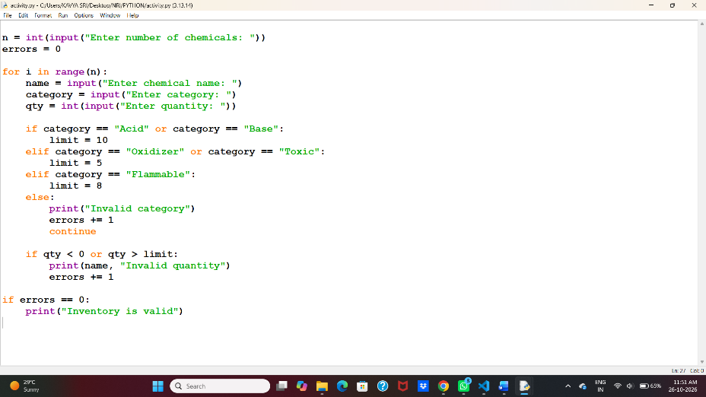
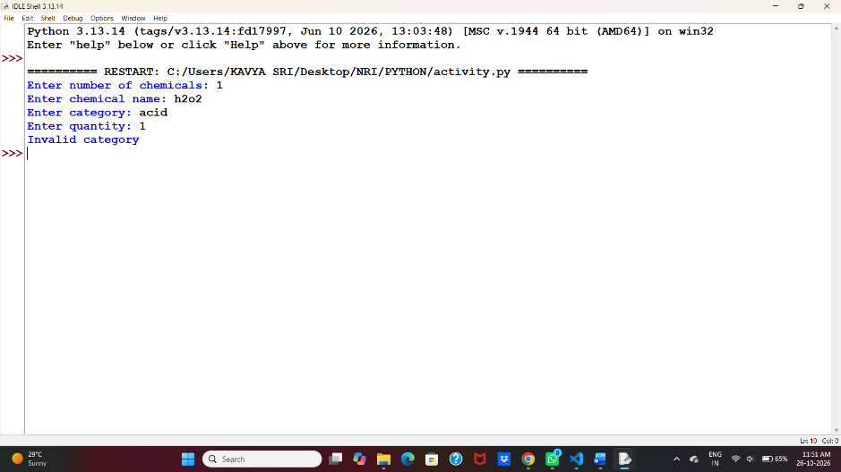

- Sample Output
Enter number of chemicals: 1
Enter chemical name: SampleA
Enter category: Toxic
Enter quantity: 3
Inventory is valid
10. Conclusion
This program uses Python lists, tuples, loops, conditional statements, and a dictionary to validate hypothetical chemical inventory records and report errors.

CASE STUDY 23: Student Timetable Conflict Detection
1. Problem Statement
To develop a Python program to detect timetable clashes by comparing course schedules, time periods, and room availability.
2. Objectives
- To store course schedules using tuples.
- To identify overlapping time periods.
- To check whether rooms are available.
- To display timetable conflicts.
3. Assumptions
- Each class has a course name, day, start time, end time, and room.
- Classes scheduled on the same day with overlapping times are considered a conflict.
- Two classes cannot use the same room at overlapping times.
4. Algorithm
- Start.
- Store course schedules in a list of tuples.
- Compare each pair of schedules.
- Check whether the day and time periods overlap.
- Check whether the same room is assigned.
- Display any conflicts found.
- Stop.

5.Flow chart
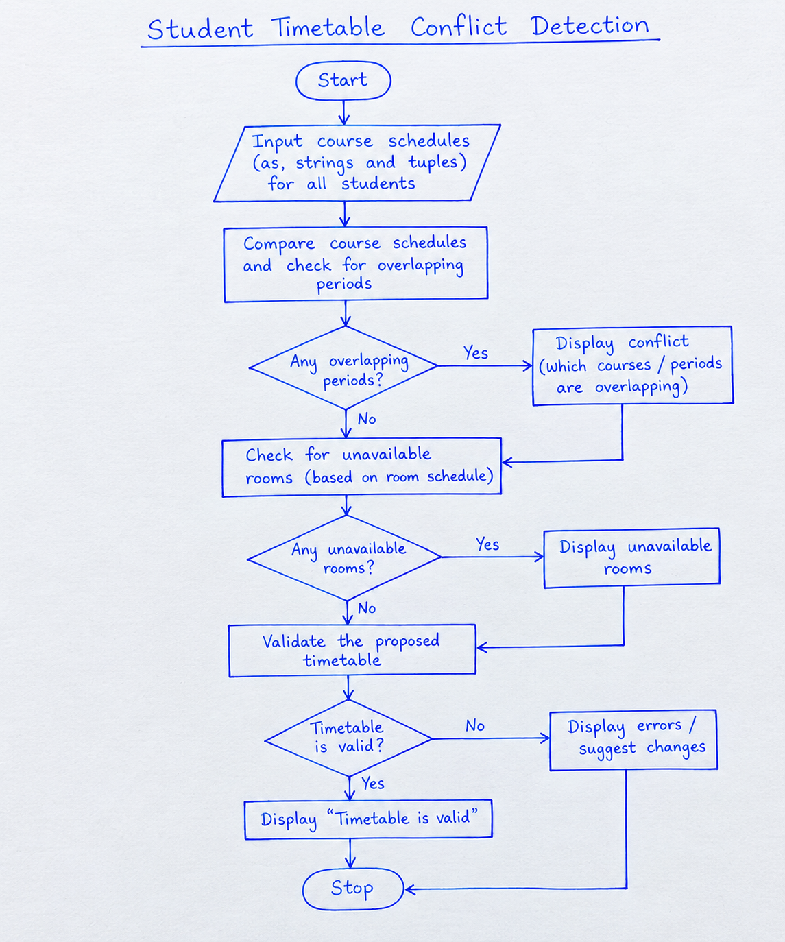

6. Pseudocode
START
Store course schedules

FOR each pair of classes
IF same day AND times overlap
IF same room
DISPLAY room conflict
ELSE
DISPLAY timetable conflict
STOP
7.Python Program
classes = [
("Python", "Monday", 9, 11, "R1"),
("Maths", "Monday", 10, 12, "R1"),
("English", "Tuesday", 9, 10, "R2")
]

conflict = False

for i in range(len(classes)):
for j in range(i + 1, len(classes)):
c1 = classes[i]
c2 = classes[j]

if c1[1] == c2[1] and c1[2] < c2[3] and c2[2] < c1[3]:
if c1[4] == c2[4]:
print(c1[0], "and", c2[0],
"have a room conflict")
else:
print(c1[0], "and", c2[0],
"have a timetable conflict")
conflict = True

if not conflict:
print("No conflicts found")8. Test Cases and Output

8.Test cases
Course 1 | Course 2 | Result
Python, Monday 9–11 | Maths, Monday 10–12 | Room conflict
Python, Monday 9–11 | English, Tuesday 9–10 | No conflict
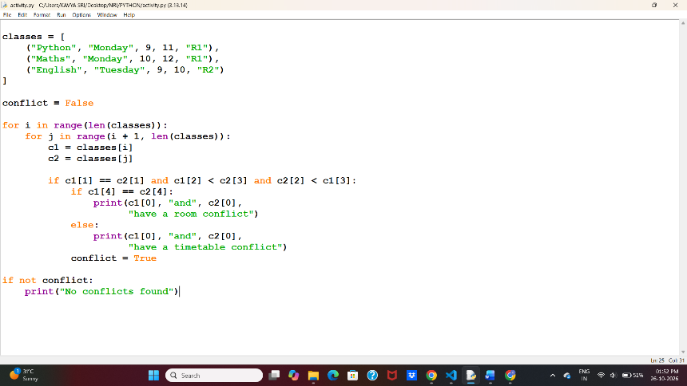
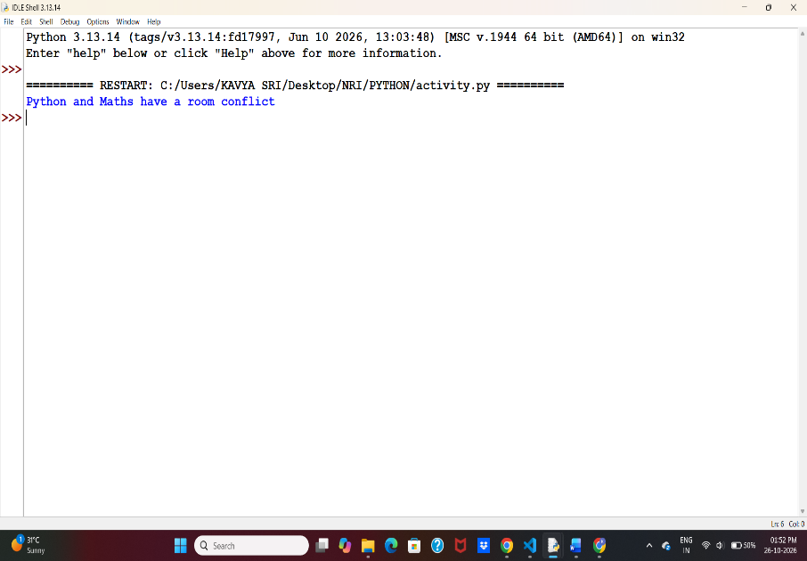
9.sampleoutput:
Python and Maths have a room conflict
10. Conclusion:
This program uses lists, tuples, nested loops, and conditional statements to detect overlapping class schedules and room conflicts.
CASE STUDY 24: Courier Charge Optimization
1. Problem Statement
To develop a Python program to calculate courier charges based on parcel weight, distance, delivery type, and restrictions, and select the cheapest eligible service.
2. Objectives
- To calculate courier charges.
- To check parcel weight and delivery type.
- To compare different courier services.
- To select the cheapest eligible service.
3. Assumptions
- Standard delivery costs ₹50 plus ₹10 per kg.
- Express delivery costs ₹100 plus ₹15 per kg.
- Maximum parcel weight is 20 kg.
- These are hypothetical charges for this assignment.
4. Algorithm
- Start.
- Input parcel weight and distance.
- Check whether the weight is valid.
- Calculate standard and express charges.
- Compare both charges.
- Display the cheapest service.
- Stop.
5. Pseudocode
START
INPUT weight, distance

IF weight <= 0 OR weight > 20
PRINT "Invalid weight"
ELSE
standard = 50 + weight * 10
express = 100 + weight * 15

IF standard < express
PRINT standard service
ELSE
PRINT express service
STOP
6. Flow chart
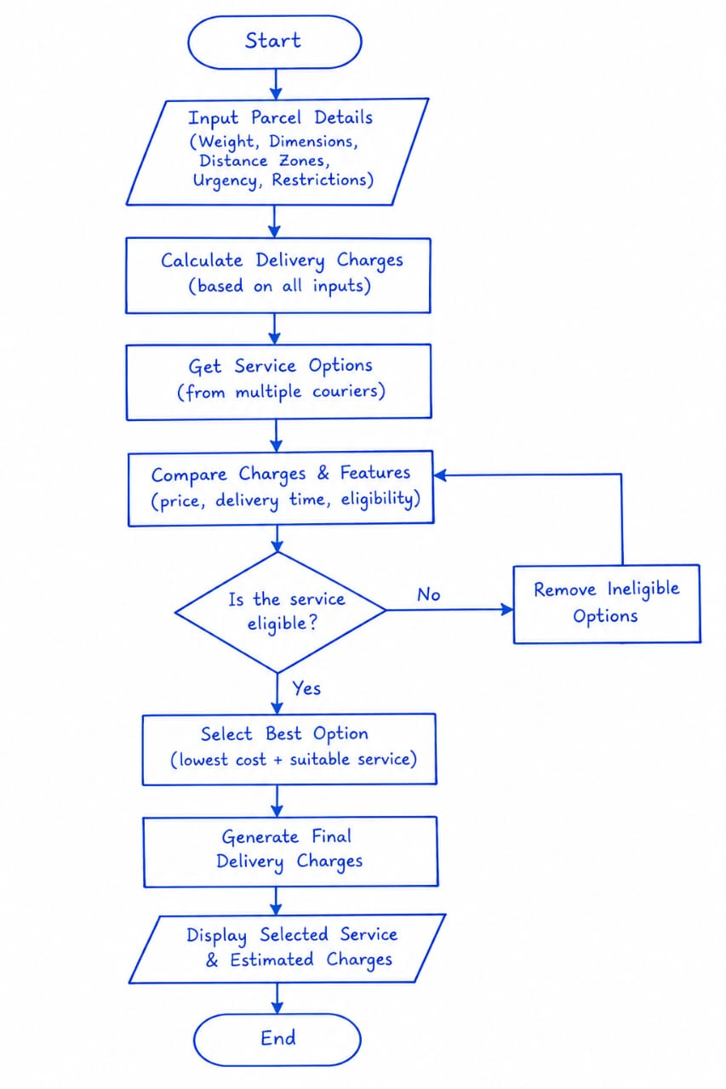

7. Python Program
weight = float(input("Enter parcel weight: "))
distance = float(input("Enter distance: "))

if weight <= 0 or weight > 20 or distance <= 0:
print("Invalid parcel details")
else:
standard = 50 + weight * 10
express = 100 + weight * 15

print("Standard charge:", standard)
print("Express charge:", express)

if standard < express:
print("Choose Standard Delivery")
else:
print("Choose Express Delivery")
8.Test Cases
Weight | Distance | Expected result
2 kg | 10 km | Standard: ₹70
5 kg | 20 km | Standard: ₹100
25 kg | 10 km | Invalid parcel details
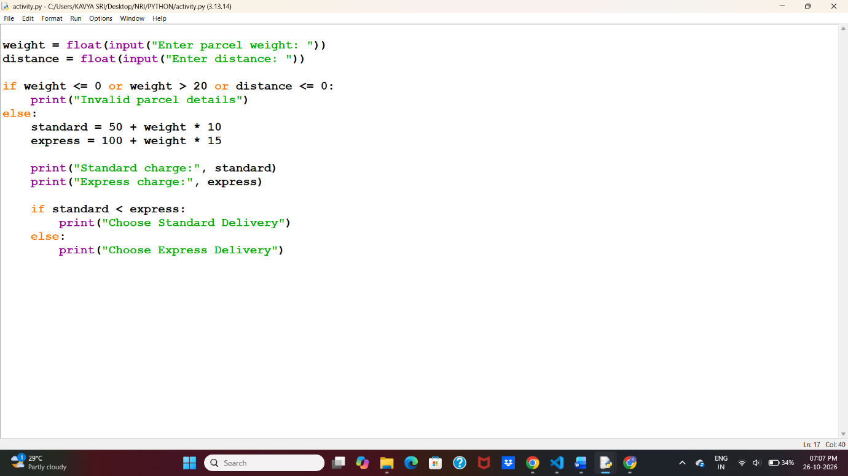

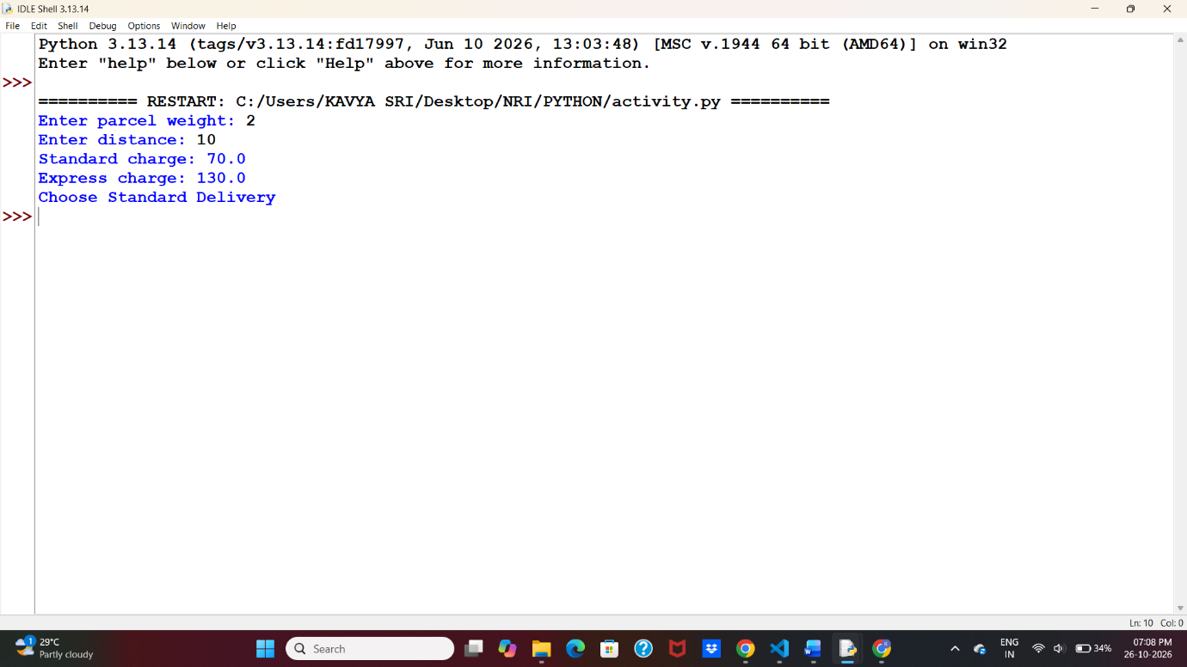
9.Sample output
Enter parcel weight: 2
Enter distance: 10
Standard charge: 70.0
Express charge: 130.0
Choose Standard Delivery
10. Conclusion
This program uses Python conditional statements and arithmetic operators to calculate courier charges and select the cheaper delivery service.

CASE STUDY 25: Progressive Water Tariff Analysis
1. Problem Statement
To develop a Python program to calculate water bills based on the quantity of water consumed using progressive tariff rates.
2. Objectives
- To calculate water consumption charges.
- To apply different rates for different consumption levels.
- To display the total water bill.
3. Assumptions
- First 100 units: ₹2 per unit.
- Next 100 units: ₹3 per unit.
- Above 200 units: ₹5 per unit.
Note: These are hypothetical rates for the assignment.
4. Algorithm
- Start.
- Input water consumption units.
- If units are within 100, calculate at ₹2 per unit.
- If units are between 101 and 200, calculate the first 100 units at ₹2 and remaining units at ₹3.
- If units exceed 200, calculate the first 100 at ₹2, next 100 at ₹3, and remaining units at ₹5.
- Display the total bill.
- Stop.
5. Pseudocode
START
INPUT units

IF units < 0
PRINT "Invalid units"
ELSE IF units <= 100
bill = units * 2
ELSE IF units <= 200
bill = 200 + (units - 100) * 3
ELSE
bill = 500 + (units - 200) * 5

PRINT bill
STOP
6.flow chart
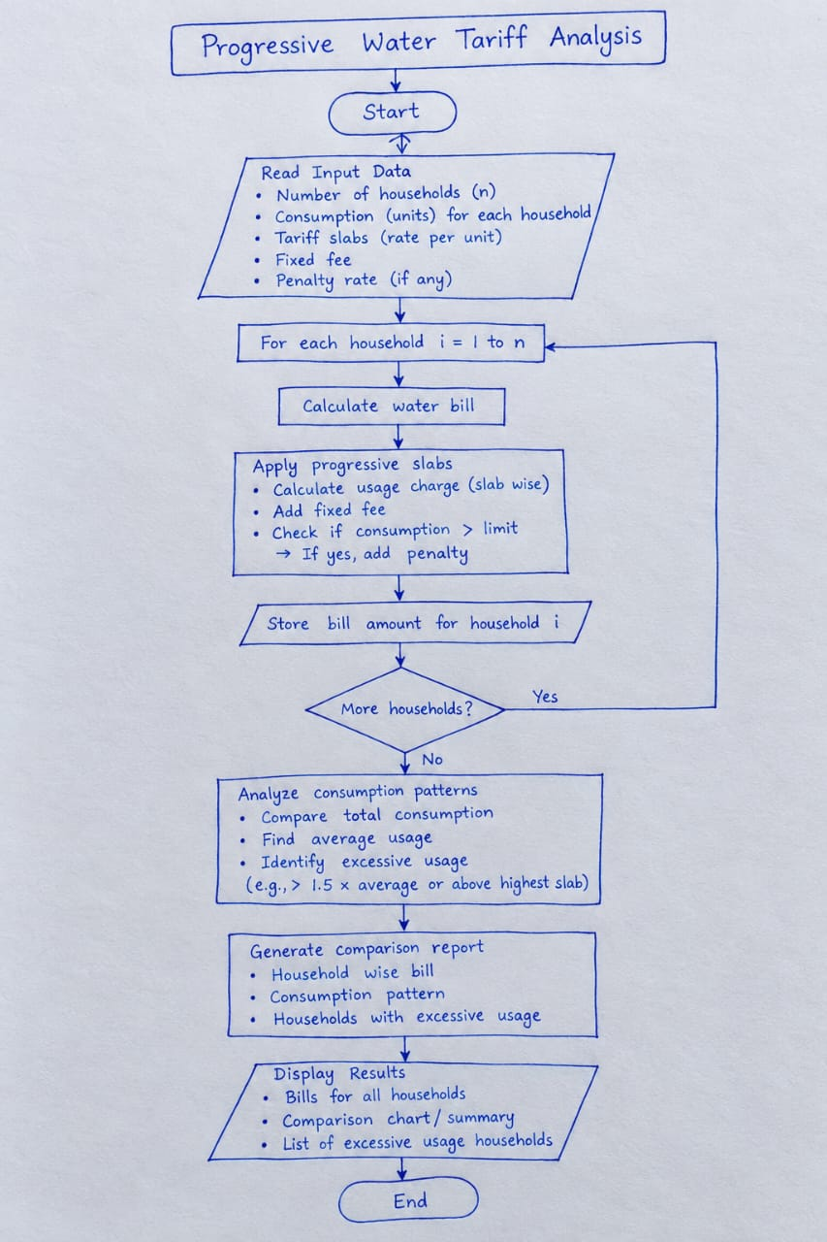

7.Python Program
units = float(input("Enter water units: "))
if units < 0:
print("Invalid units")
elif units <= 100:
bill = units * 2
elif units <= 200:
bill = 200 + (units - 100) * 3
else:
bill = 500 + (units - 200) * 5
if units >= 0:
print("Water bill: Rs.", bill)
8. Test Cases
Water units | Bill
50 | ₹100
150 | ₹350
250 | ₹750

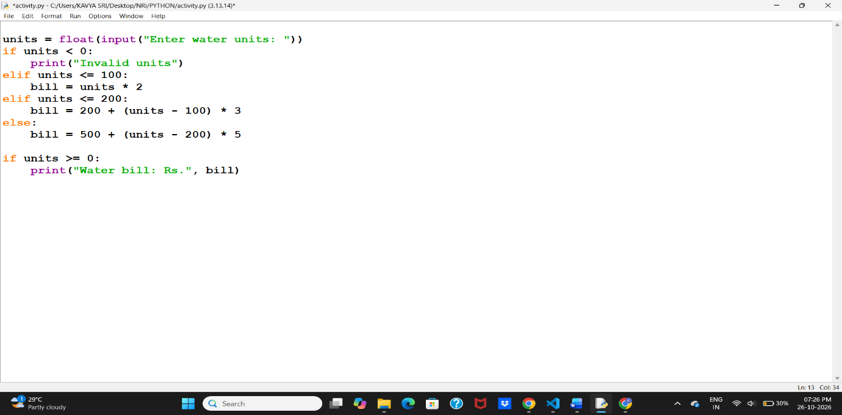
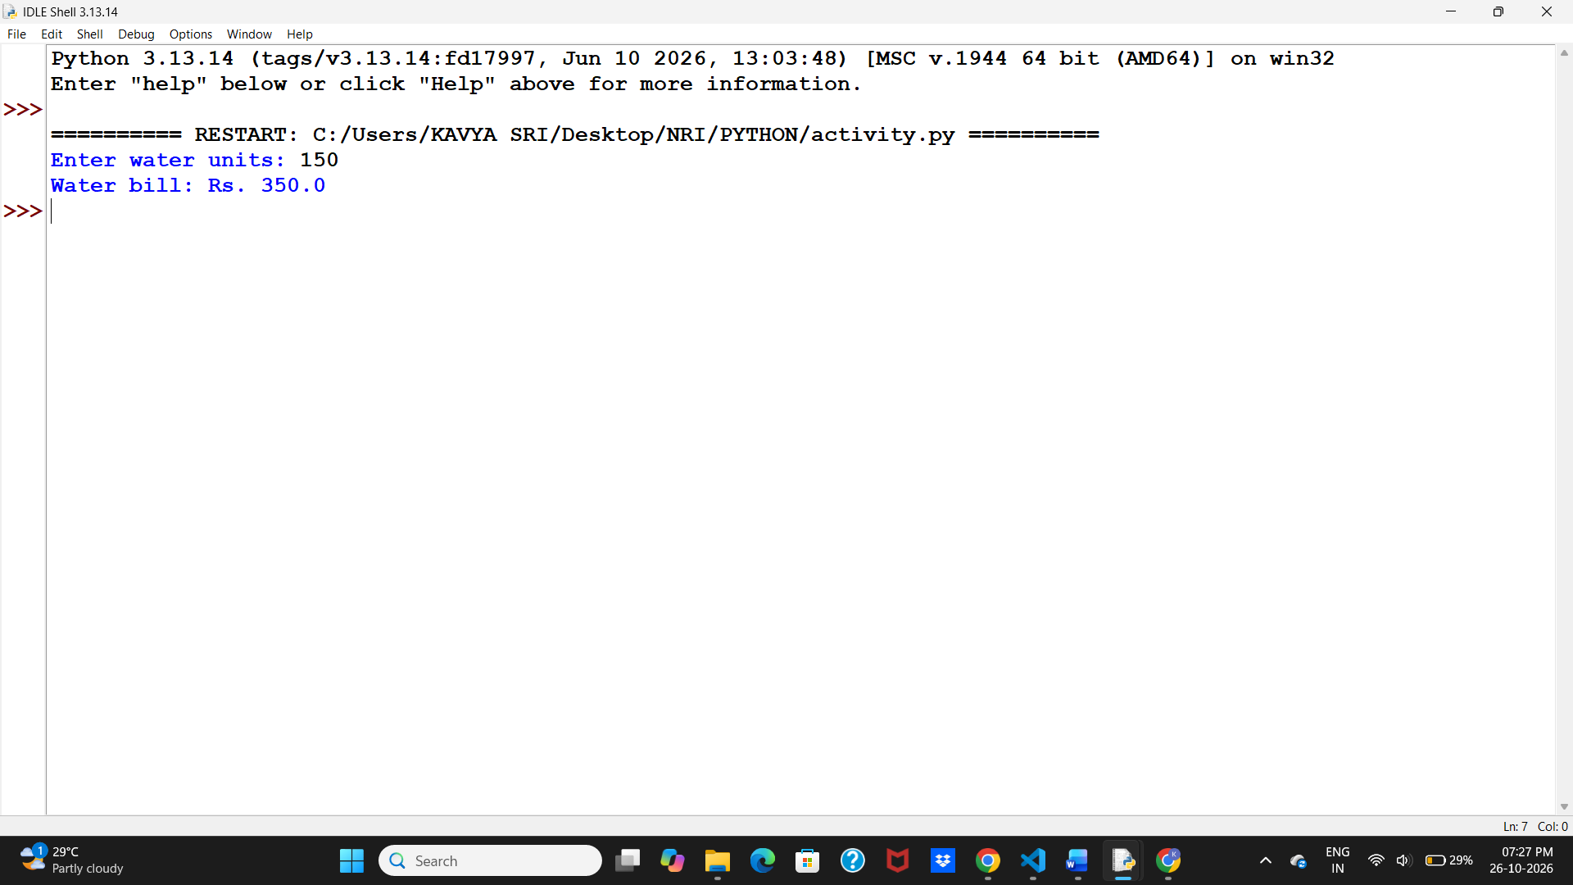
9.Sample output
Enter water units: 150
Water bill: Rs. 350.0
10. Conclusion
This program calculates water bills using progressive tariff rates and Python conditional statements.

CASE STUDY 26: Nested Loop Examination Seating Generator
1. Problem Statement
To develop a Python program to generate an examination seating arrangement using rows, columns, and nested loops.
2. Objectives
- To create a seating arrangement.
- To display row and column numbers.
- To reserve selected seats.
- To use nested loops for seat generation.
3. Assumptions
- The classroom has 3 rows and 4 columns.
- Seat R2C2 is reserved.
- All other seats are available.
4. Algorithm
- Start.
- Set the number of rows and columns.
- Use nested loops to visit each seat.
- Check whether the seat is reserved.
- Display the seat as reserved or available.
- Stop.
5. Pseudocode
START
SET rows = 3, columns = 4

FOR each row
FOR each column
IF seat is reserved
PRINT "Reserved"
ELSE
PRINT "Available"
STOP
6.flow chart
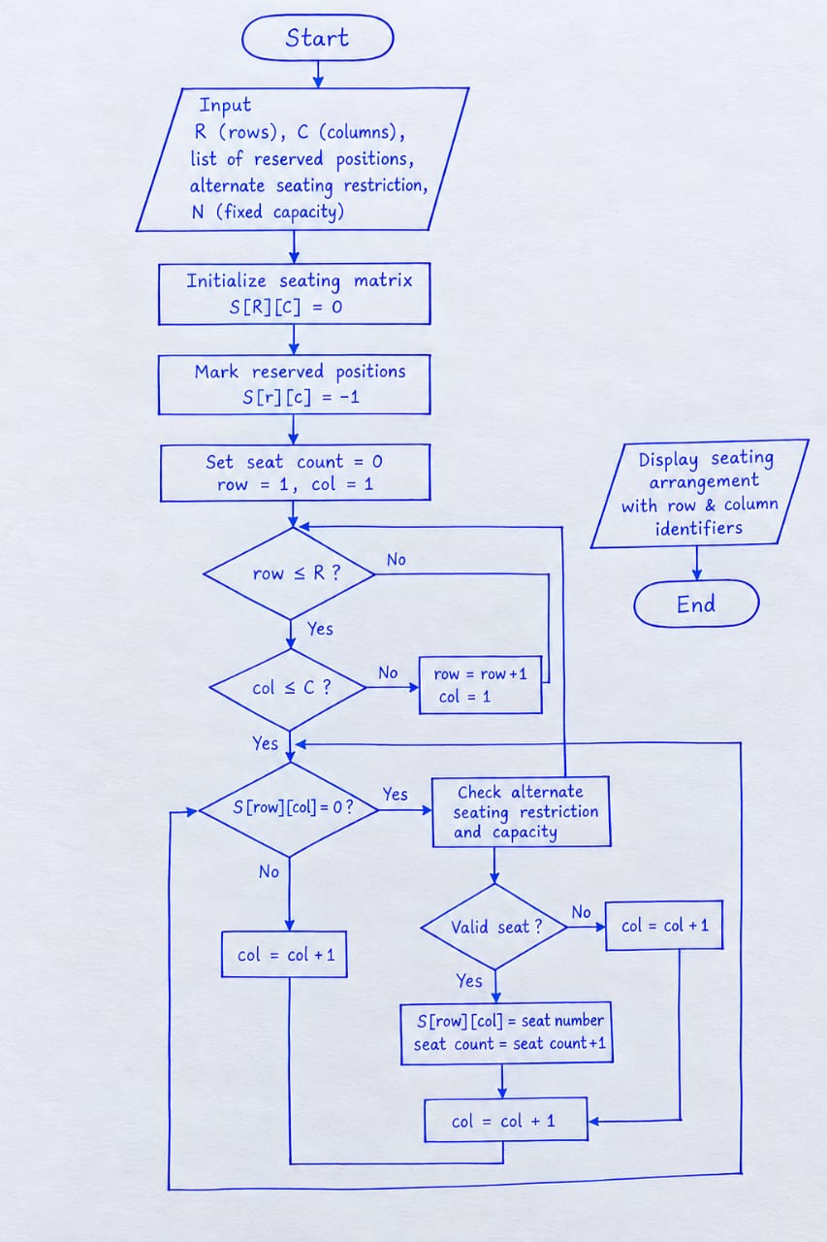

- Python Program
rows = 3
cols = 4
reserved = [(2, 2)]
for i in range(1, rows + 1):
for j in range(1, cols + 1):
if (i, j) in reserved:
print("R", end=" ")
else:
print("A", end=" ")
print()
8.Test Cases
Test Case | Input | Expected Output
1 | Rows = 3, Columns = 4 | 3 rows and 4 columns display avuthayi
2 | Seat R2C2 | Reserved (R)
3 | Other seats | Available (A)
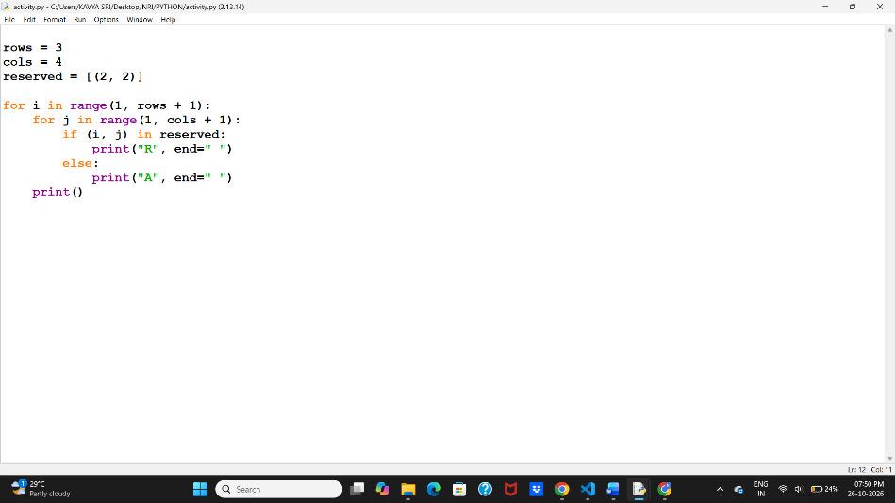

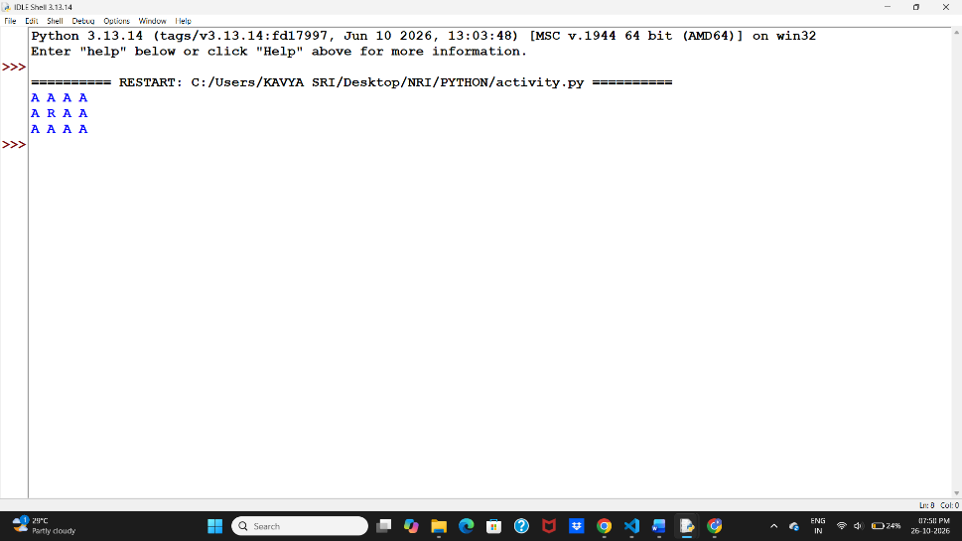
9. Sample Output
A A A A
A R A A
A A A A
A = Available seat, R = Reserved seat.
10. Conclusion
This program uses nested loops, tuples, and conditional statements to generate an examination seating arrangement and identify reserved seats.

CASE STUDY 27: Advanced Numeric Pattern Generator
1. Problem Statement
To develop a Python program that generates numeric patterns using loops based on the number of rows entered by the user.
2. Objectives
- To generate numeric patterns.
- To use loops and nested loops.
- To improve logical thinking.
3. Assumptions
- The user enters the number of rows.
- The number of rows must be greater than zero.
- The program prints a simple number pattern.
4. Algorithm
- Start.
- Input the number of rows.
- Check whether the number is greater than zero.
- Use nested loops to print the number pattern.
- Display the pattern.
- Stop.
5. Pseudocode
START
INPUT rows

IF rows <= 0
PRINT "Invalid input"
ELSE
FOR i = 1 TO rows
FOR j = 1 TO i
PRINT j
PRINT new line
STOP
6.Flowchart

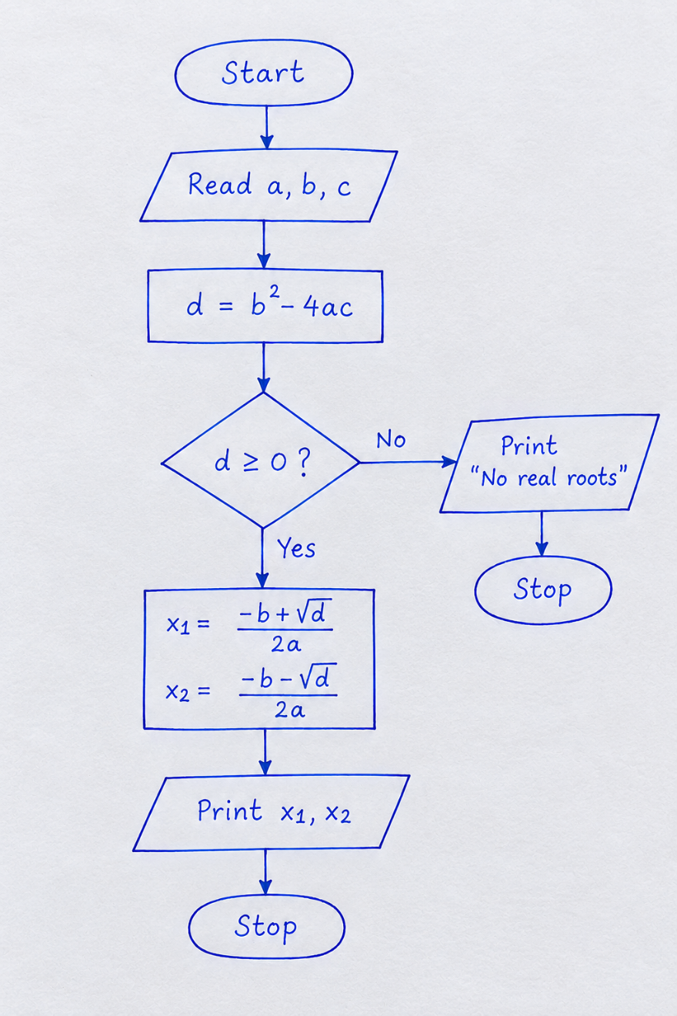
7.Python Program
rows = int(input("Enter number of rows: "))

if rows <= 0:
print("Invalid input")
else:
for i in range(1, rows + 1):
for j in range(1, i + 1):
print(j, end=" ")
print()
8.Test cases
Test Case | Input | Expected Output
1 | 3 | Number pattern with 3 rows
2 | 5 | Number pattern with 5 rows
3 | 0 | Invalid input
4 | -2 | Invalid input

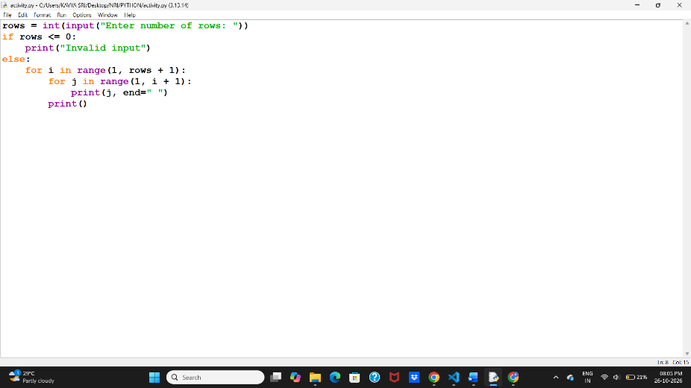

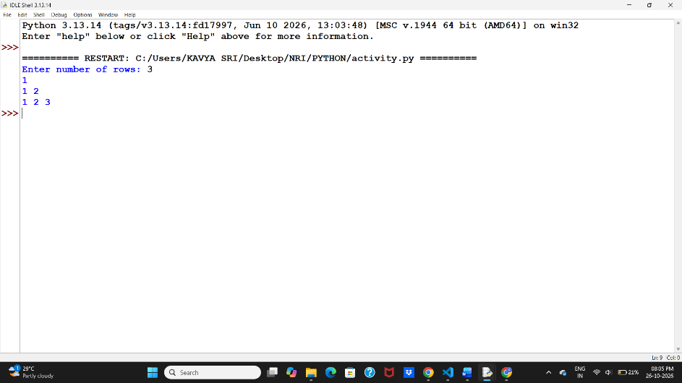

9.Sample Output:
Enter number of rows: 3
1
1 2
1 2 3
10. Conclusion
The program generates numeric patterns using nested loops and validates the number of rows entered by the user.

CASE STUDY 27: Repeated Transaction Detection
1. Problem Statement
To develop a Python program that identifies repeated transactions in a list of transactions.
2. Objectives
- To detect duplicate transactions.
- To use lists and loops in Python.
- To identify repeated transaction amounts.
3. Assumptions
- The user enters the number of transactions.
- Transaction amounts are entered as numbers.
- If an amount appears more than once, it is considered repeated for this simple example.
4. Algorithm
- Start.
- Input the number of transactions.
- Read each transaction amount into a list.
- Check whether any amount is repeated.
- Display the repeated amounts or a message if there are none.
- stop
5.pseudo code
START
INPUT rows

IF rows <= 0
PRINT "Invalid input"
ELSE
FOR i = 1 TO rows
FOR j = 1 TO i
PRINT j
PRINT new line

STOP

6. Flowchart
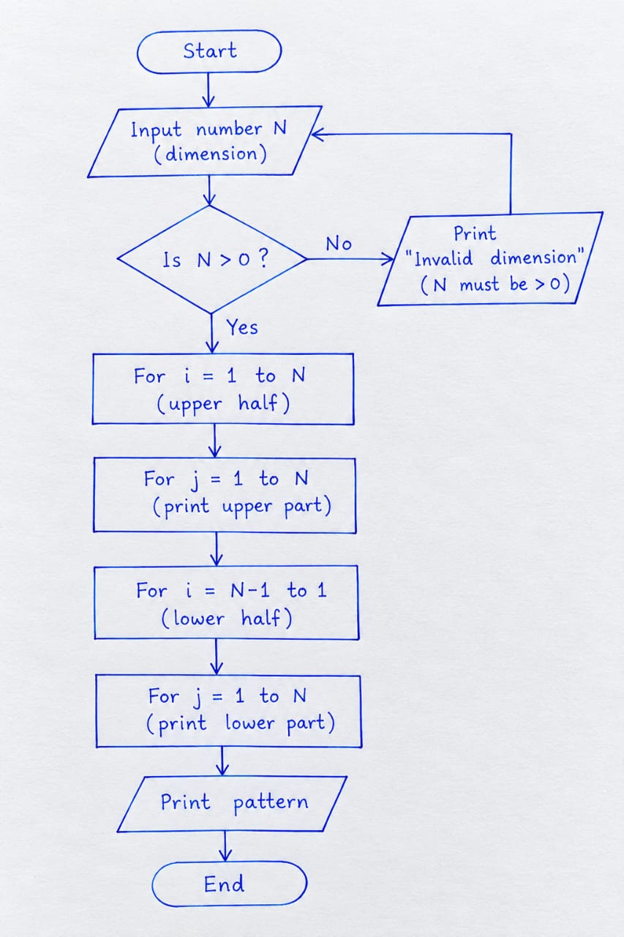

- Python Program
transactions = [
("T101", 500),
("T102", 2000),
("T101", 500),
("T103", 7000)
]

suspicious = []
ids = []
limit = 5000

for tid, amount in transactions:
if tid in ids or amount > limit:
suspicious.append((tid, amount))
ids.append(tid)

print("Suspicious transactions:")
for item in suspicious:
print(item)
8. Test Cases and Output
Test Case | Transaction | Expected Result
1 | T101, 500 (first entry) | Normal transaction
2 | T101, 500 (repeated ID) | Suspicious
3 | T103, 7000 | Suspicious: amount exceeds limit
4 | T104, 300 | Normal transaction

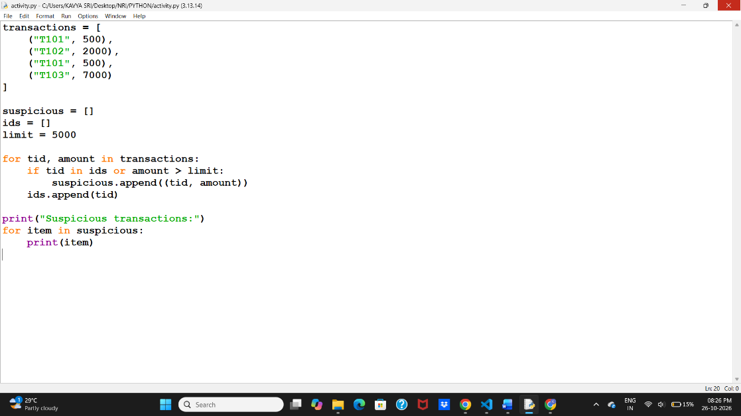
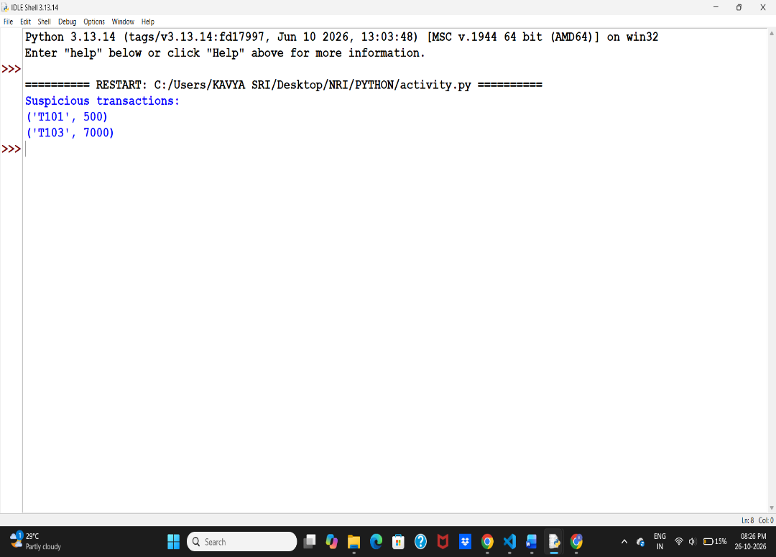

9.sample Output:
Suspicious transactions:
('T101', 500)
('T103', 7000)
10. Conclusion
The program identifies duplicate transaction IDs and transactions exceeding the specified amount limit using lists and loops.

Think

To pick up a draggable item, press the space bar. While dragging, use the arrow keys to move the item. Press space again to drop the item in its new position, or press escape to cancel.

CASE STUDY 28: Repeated Transaction Detection
1. Problem Statement
To develop a Python program that identifies repeated transactions in a list of transactions.
2. Objectives
- To detect duplicate transactions.
- To use lists and loops in Python.
- To identify repeated transaction amounts.
3. Assumptions
- The user enters the number of transactions.
- Transaction amounts are entered as numbers.
- If an amount appears more than once, it is considered repeated for this simple example.
4. Algorithm
- Start.
- Input the number of transactions.
- Read each transaction amount into a list.
- Check whether any amount is repeated.
- Display the repeated amounts or a message if there are none.
- Stop.
5.pseudo code
START
SET transactions list
SET suspicious list
SET ids list
SET limit = 5000

FOR each transaction
READ transaction ID and amount

IF ID already exists OR amount > limit
ADD transaction to suspicious list

ADD ID to ids list

PRINT suspicious transactions
STOP

6. Flowchart

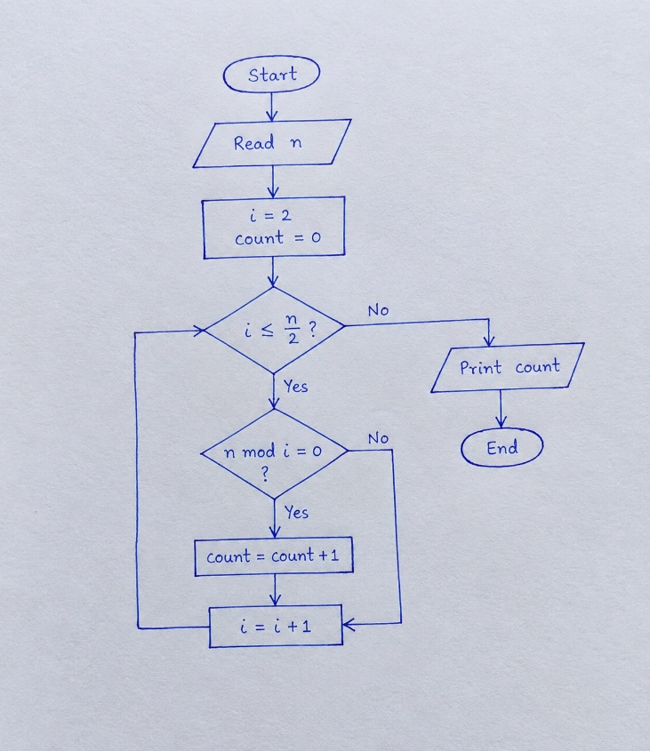
7.Python Program
transactions = [
("T101", 500),
("T102", 2000),
("T101", 500),
("T103", 7000)
]

suspicious = []
ids = []
limit = 5000

for tid, amount in transactions:
if tid in ids or amount > limit:
suspicious.append((tid, amount))
ids.append(tid)

print("Suspicious transactions:")
for item in suspicious:
print(item)
8. Test Cases and Output
Test Case | Transaction | Expected Result
1 | T101, 500 (first entry) | Normal transaction
2 | T101, 500 (repeated ID) | Suspicious
3 | T103, 7000 | Suspicious: amount exceeds limit
4 | T104, 300 | Normal transaction
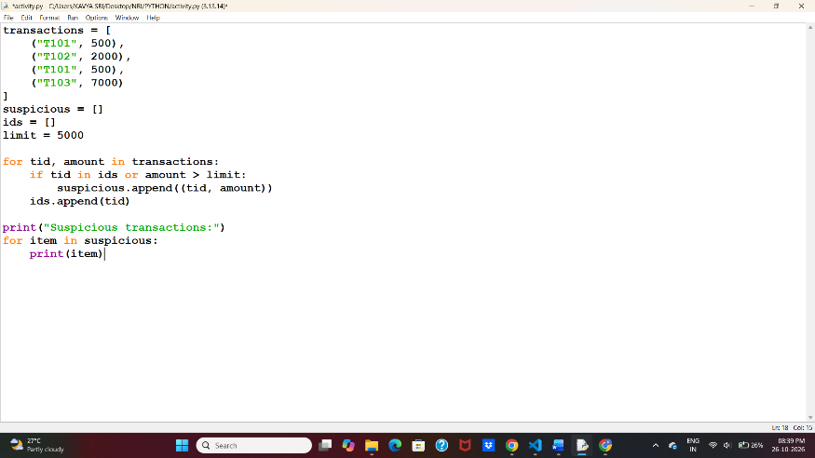

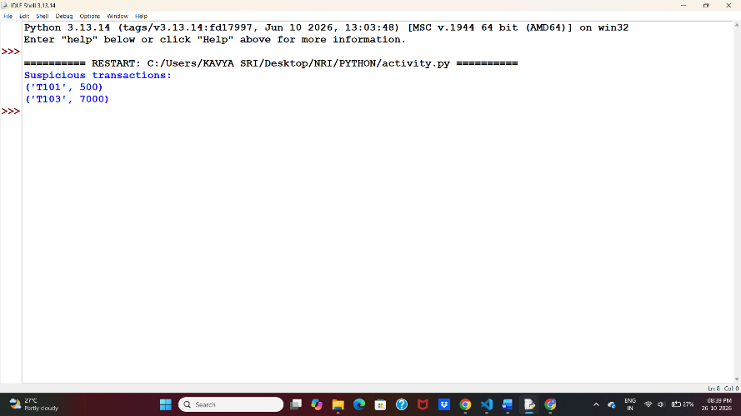

9.Sample Output
Suspicious transactions:
('T101', 500)
('T103', 7000)
10. Conclusion
The program identifies duplicate transaction IDs and transactions exceeding the specified amount limit using lists and loops.

CASE STUDY 29: Password Policy Validation Engine
1. Problem Statement
To develop a Python program that checks whether a password satisfies specified rules, such as minimum length, character types, repeated characters, and prohibited words.
2. Objectives
- To validate password rules.
- To use strings and conditional statements.
- To identify and display password errors.
3. Assumptions
- Minimum password length is 8 characters.
- Password must contain uppercase, lowercase, and numeric characters.
- Password must not contain the word password.
- Three or more consecutive identical characters are not allowed.
4. Algorithm
- Start.
- Input a password.
- Check its length.
- Check uppercase, lowercase, and numeric characters.
- Check repeated characters and prohibited words.
- Display whether the password is valid or invalid.
- Stop.
5. Pseudocode
START
INPUT password
SET errors = 0

IF length < 8
PRINT "Too short"
IF uppercase is missing
PRINT "Uppercase missing"
IF lowercase is missing
PRINT "Lowercase missing"
IF digit is missing
PRINT "Digit missing"
IF password contains "password"
PRINT "Prohibited word found"
IF three consecutive characters are same
PRINT "Repeated characters found"

IF no errors
PRINT "Valid password"

STOP
6. Flowchart

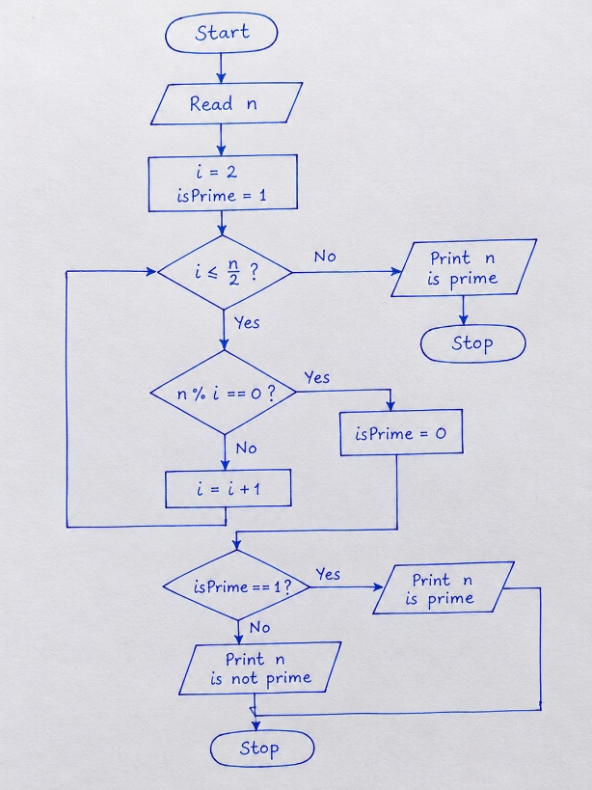
7.Python Program
p = input("Enter password: ")
errors = []

if len(p) < 8:
errors.append("Minimum 8 characters required")

if not any(c.isupper() for c in p):
errors.append("Uppercase letter missing")

if not any(c.islower() for c in p):
errors.append("Lowercase letter missing")

if not any(c.isdigit() for c in p):
errors.append("Digit missing")

if "password" in p.lower():
errors.append("Prohibited word found")

for i in range(len(p) - 2):
if p[i] == p[i+1] == p[i+2]:
errors.append("Repeated characters found")
break

if len(errors) == 0:
print("Valid password")
else:
print("Invalid password")
for error in errors:
print(error)
8. Test Cases and Output
Test Case | Input | Expected Output
1 | Hello123 | Valid password
2 | abc12 | Invalid — too short and missing uppercase
3 | PASSWORD123 | Invalid — lowercase missing and prohibited word found
4 | Abcdddd123 | Invalid — repeated characters found

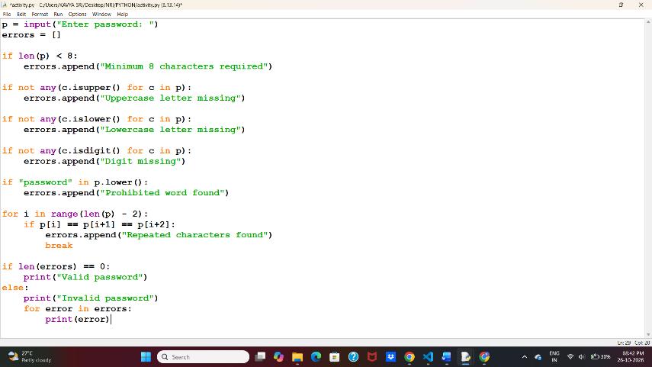
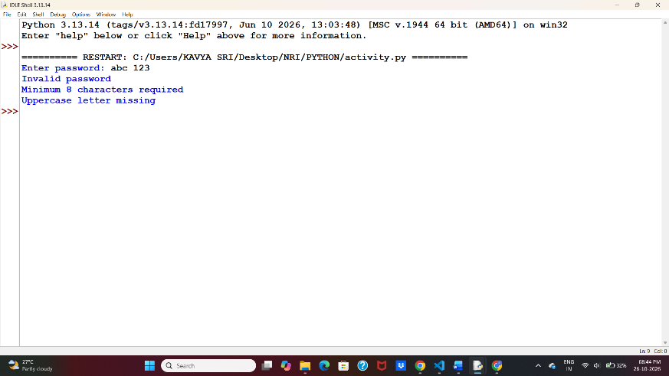
9.Sample Output:
Enter password: abc12
Invalid password
Minimum 8 characters required
Uppercase letter missing
10. Conclusion
The program validates passwords using string operations, loops, and conditional statements and displays the rules that are not satisfied.

CASE STUDY 30: Student Email and Identifier Validation
1. Problem Statement
To develop a Python program that validates student email addresses and registration IDs based on specified formatting rules and identifies invalid entries.
2. Objectives
- To validate student email addresses.
- To check registration ID formats.
- To identify missing or incorrect components.
3. Assumptions
- Email must contain @ and end with .com.
- Registration ID must start with NRI followed by digits.
- Invalid entries should display an error message.
4. Algorithm
- Start.
- Input student email and registration ID.
- Check the email format.
- Check the registration ID format.
- Display valid or invalid messages.
- Stop.
5. Pseudocode
START
INPUT email, reg_id

IF email contains "@" and ends with ".com"
PRINT "Valid email"
ELSE
PRINT "Invalid email"

IF reg_id starts with "NRI" and remaining characters are digits
PRINT "Valid registration ID"
ELSE
PRINT "Invalid registration ID"

STOP
6. Flowchart

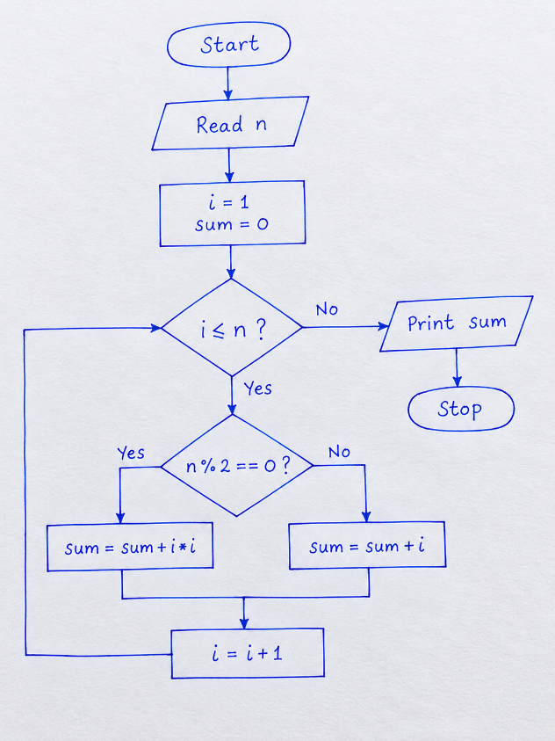
7.Python Program
email = input("Enter student email: ")
reg_id = input("Enter registration ID: ")
if "@" in email and email.endswith(".com"):
print("Valid email")
else:
print("Invalid email")
if reg_id.startswith("NRI") and reg_id[3:].isdigit():
print("Valid registration ID")
else:
print("Invalid registration ID")
8. Test Cases and Output
Test Case | Email | Registration ID | Expected Result
1 | student@gmail.com | NRI123 | Both valid
2 | studentgmail.com | NRI123 | Invalid email
3 | student@gmail.com | ABC123 | Invalid registration ID
4 | student@gmail.com | NRIABC | Invalid registration ID

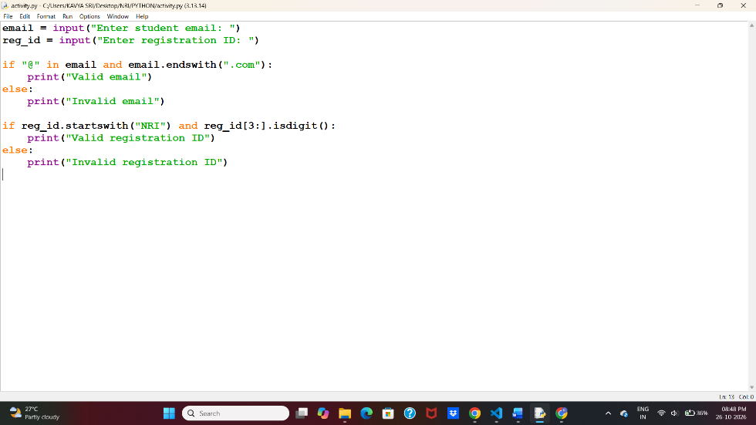
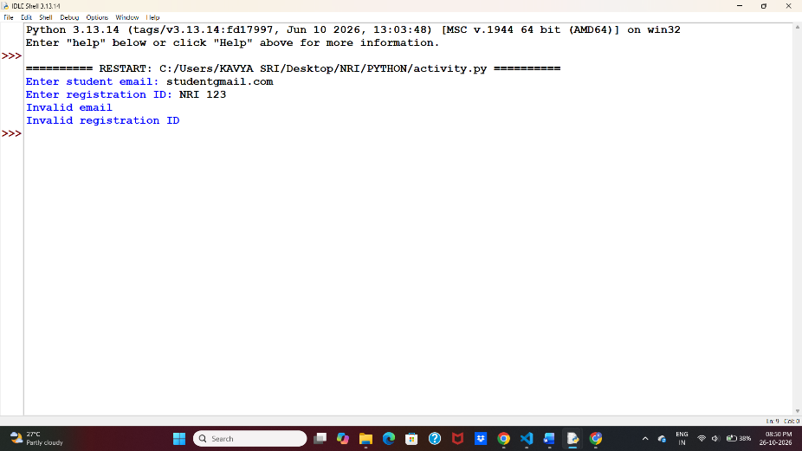
9.Sample Output
Enter student email: student@gmail.com
Enter registration ID: NRI123
Valid email
Valid registration ID
10. Conclusion
The program validates student email addresses and registration IDs using string methods and conditional statements. It displays whether each entry is valid or invalid.

